Lecturer’s name: N/A | Date: Day 9
Course: Math | Unit: Equivalent Forms of Fractions, Decimals, and Percents
Unit Duration: 10 days | Lesson Duration: 1 day
TEKS: 6.4E, 6.5B, 6.2D, | Lesson Part 1
Topic: Percent Application Problems

Lesson objectives:
- SWBAT review key points in preparation for the unit exam.
- SWBAT to apply learned knowledge on real-world, multiple choice problems.

Essential Questions:
How are percentages used in everyday life?
What objectives have I been struggling with and how can I ask for help from my teacher and peers?

LYS Methodology

Be (Character/Values/Principles) - Educational, Financial, Vocational, Spiritual, Cultural - How can I use the time given in class to be purposeful in the unit review? How can I seek feedback from my peers and teachers and let them guide me through unfamiliar content?

Know (What resources are available to the student/ How can they use them) - Educational and Spiritual, Vocational - What kinds of questions do I need to ask others that can mentor and provide guidance in matters that I am not confident in?

Do (Execute with Excellence) - Educational, Financial, Spiritual and Social - How do these strategies help me be a resourceful person that is mindful of time and humble enough to ask for help?

Resources (Include Technology):
Instructional Input - Asynchronous
AS: Anticipatory Set (Introduction)
- Student warm up - Review Warm up
- Review how to solve problems like these and ask probing questions that gets student invested in the process not just the solution

GP: Guided Practice (They do)
- Students engage in independent practice after the warm up
- Begin with page 2 from this review as it walks students through what they learned at the beginning of the unit
- After 15 minutes have passed, allow for 8 minutes for students to COLLABORATE (not cheat) with table peers and ask questions such as:
  - How can I go from a decimal to percent?
  - How can I find place value?
  - How can I find the fractions?
  - How can I simplify?
- PUSH QUESTIONS to be more than “What is the answer?”

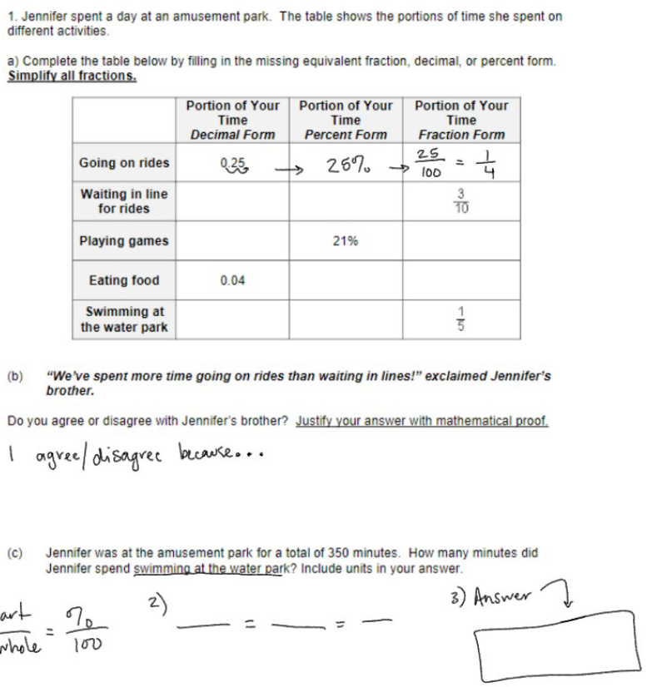

M: Modeling #2 (I do)
- After students collaborate, have them come back and go over answers - discussion style
- Continue asking probing questions, how did you get that answer? What steps did you take? Etc.
- Check for work

GP: Guided Practice (They do)
- Practice Part 2
- 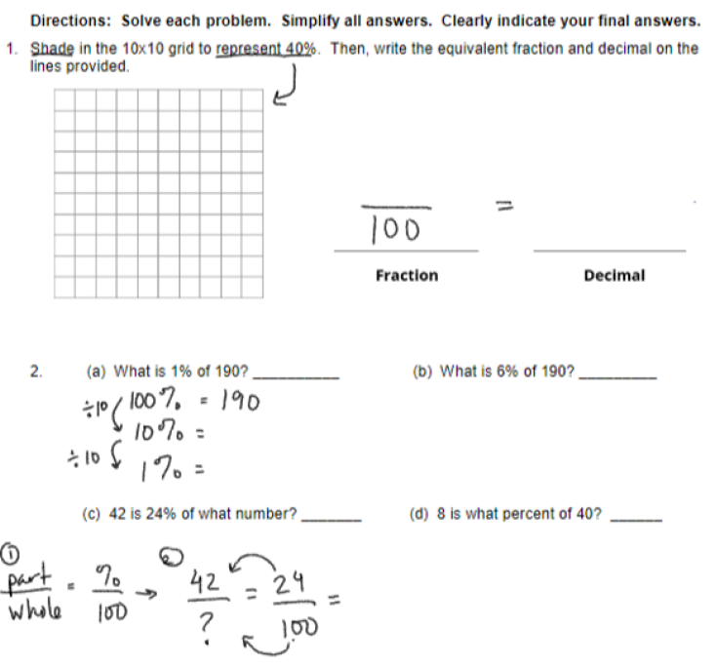

Instructional Input - Synchronous
AS: Anticipatory Set (Introduction)
- Student warm up -
- Review how to solve problems like these and ask probing questions that gets student invested in the process not just the solution

GP: Guided Practice (They do)
- Students engage in independent practice after the warm up
- Begin with page 2 from this review as it walks students through what they learned at the beginning of the unit
- After 15 minutes have passed, allow for 8 minutes for students to COLLABORATE (not cheat) with table peers and ask questions such as:
  - How can I go from a decimal to percent?
  - How can I find place value?
  - How can I find the fractions?
  - How can I simplify?
- PUSH QUESTIONS to be more than “What is the answer?”



M: Modeling #2 (I do)
- After students collaborate, have them come back and go over answers - discussion style
- Continue asking probing questions, how did you get that answer? What steps did you take? Etc.

Independent Practice/ Homework
- Students complete online problems
  - Online Review Practice 1
  - Online Review Practice 2

Lesson Close

Spiritual
“Don’t be afraid to ask for help. Nobody gets through college on their own” - Michelle Obama

Be (Character/Values/Principles) - Educational, Financial, Vocational, Spiritual, Cultural - How can I use the time given in class to be purposeful in the unit review? How can I seek feedback from my peers and teachers and let them guide me through unfamiliar content?

Taking initiative in seeking feedback and knowing HOW to do so are skills that all students must possess, which is everyone. Individuals that value growth and betterment of oneself will be pushed to constantly ask for help and be mindful of moments that are placed for that reason. Review days are not just to do work over and over again until you see the answer. Review days are about learning the process on how you go from point A to point B.

Learning the kinds of questions to ask peers, mentors, friends and loved ones for feedback will differ with each group. Understanding what you do not know is a strength because that gives you a starting point and knowing what you don’t know only happens when you attempt something. Trying and failing will be part of the process to make you a student that is mindful, humble and seeks for help.

